**Release Management –**

**Once the PM creates the REL**

1 - QA Dashboard should be added to the REL item in the description area, below the Scope –

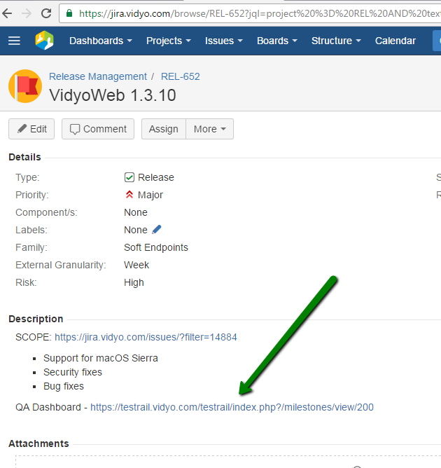

2 – Click on the “Release Sign-Off – QA” –

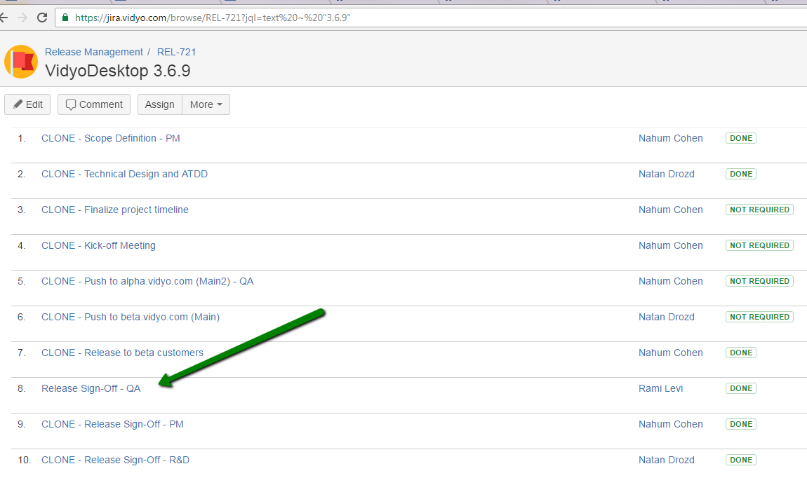

3 – Assign the QA Checklist to the relevant person – Manager/Leader

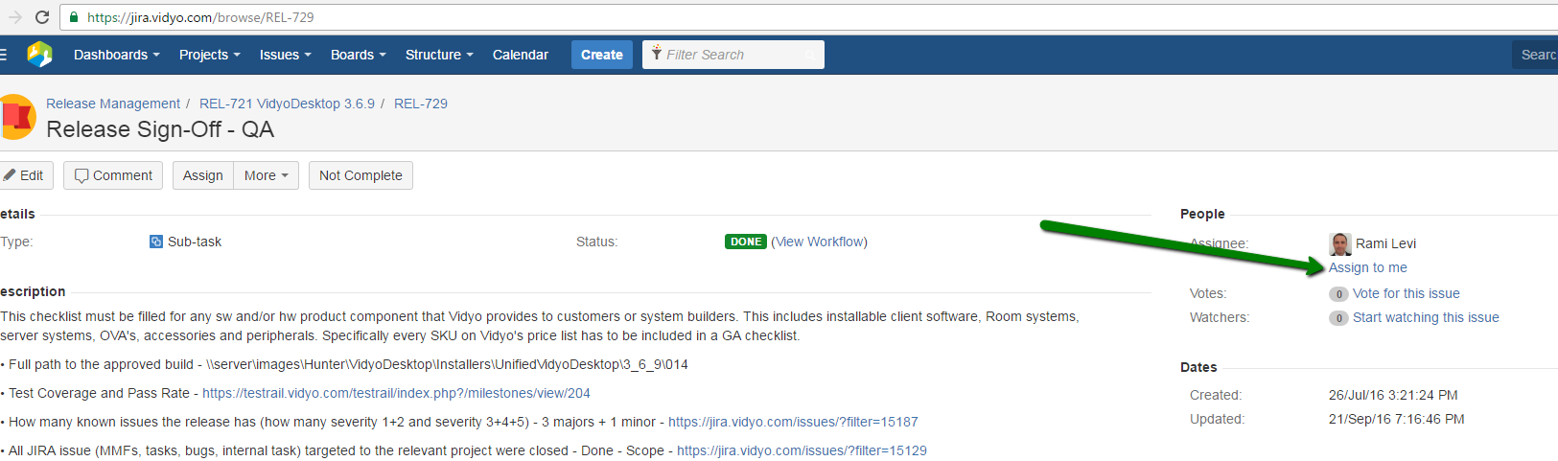

Thanks,

Liat Gibli